Supplementary Material
CONTENTS
- Code of population model in MLXTRAN® code.
- Code of the simulated models for Simulx.
- Code model for the simulated data from studies in humans.
- Figure S1: Observed versus predicted concentrations in log-log plots. Left panel shows the observations versus populations predictions. The right panel shows the observations versus individual predictions.
- Figure S2: Plots of the population/individual-weighted residuals (PWRES and IWRES) versus predictions/time
- Figure S3: Box plots for covariate effect of the breed in the typical values of the clearance of paracetamol in dogs.
- Figure S4: Box plots for covariate effect of the anaesthesia in the typical values of the intercompartmental clearance of paracetamol in dogs. Left box for animals without anaesthesia (group 0) and right box under general anaesthesia (group 1).
- Table S1. Probability of target attainment (PTA) of simulated dose regimen of paracetamol using as target the percentage of individuals that all concentrations remain above the dosing interval. Values calculated with concentrations from 1 to 20 µg/ml using the Monte Carlo simulation (n = 1000).
- Web address of 3D interactive widgets for simulation plots dosing regimen (x axis), target concentration (y axis) and probability of target attainment (z axis).

Code of population model in MLXTRAN® code.

DESCRIPTION: BICOMPARTMENTAL MODEL FOR PLASMA PARAMETRIZED BY CL AND Q WITH AUC VALUES

[LONGITUDINAL]
input = {Cl, V1, Q, V2}

PK:
depot(adm=1, target=A1) ; IV administration

EQUATION:
odeType = stiff

t_0=0
A1_0=0 ; IV central compartment

ddt_A1 = - Cl/V1*A1 - Q/V1*A1 + Q/V2*A2
ddt_A2 = Q/V1*A1 - Q/V2*A2

C1 = A1/V1 ; Plasma and serum concentrations at central compartment

AUC_0 = 0
ddt_AUC = C1
Vss = V1 + V2
kel = Cl/V1
k12 = Q/V1
k21 = Q/V2
Beta = 0.5 *(kel + k12 + k21 -((k12 + k21 + kel)^2 - (4 * k21 * kel))^0.5)
HL = 0.693/Beta

OUTPUT:
output = {C1}
table = {AUC, Vss, HL}

Code of the simulated models for Simulx.

[COVARIATE]
input = {Anaesthesia, Breed}

Anaesthesia = {type=categorical, categories={'0', '1'}}
Breed = {type=categorical, categories={'BEAGLE', 'GREYHOUND', 'LABRADOR', 'Various'}}

DEFINITION:
tBreed_LAB_GREY =
{
transform = Breed,
categories = {
'G_BEAGLE_Various' = {'BEAGLE', 'Various'},
'G_GREYHOUND' = {'GREYHOUND'},
'G_LABRADOR' = {'LABRADOR'} },
reference = 'G_BEAGLE_Various'
}

[INDIVIDUAL]
input = {Cl_pop, omega_Cl, Q_pop, omega_Q, tBreed_LAB_GREY, beta_Cl_tBreed_LAB_GREY_G_GREYHOUND, beta_Cl_tBreed_LAB_GREY_G_LABRADOR, gamma_Q, Anaesthesia, beta_Q_Anaesthesia_1, V1_pop, omega_V1, V2_pop, omega_V2, gamma_Cl, gamma_V1, gamma_V2}

tBreed_LAB_GREY = {type=categorical, categories={'G_BEAGLE_Various', 'G_GREYHOUND', 'G_LABRADOR'}}
Anaesthesia = {type=categorical, categories={'0', '1'}}

DEFINITION:
Cl = {distribution=logNormal, typical=Cl_pop, covariate=tBreed_LAB_GREY, coefficient={0, beta_Cl_tBreed_LAB_GREY_G_GREYHOUND, beta_Cl_tBreed_LAB_GREY_G_LABRADOR}, varlevel={id, id*occ}, sd={omega_Cl, gamma_Cl}}
Q = {distribution=logNormal, typical=Q_pop, covariate=Anaesthesia, coefficient={0, beta_Q_Anaesthesia_1}, varlevel={id, id*occ}, sd={omega_Q, gamma_Q}}
V1 = {distribution=logNormal, typical=V1_pop, varlevel={id, id*occ}, sd={omega_V1, gamma_V1}}
V2 = {distribution=logNormal, typical=V2_pop, varlevel={id, id*occ}, sd={omega_V2, gamma_V2}}

[LONGITUDINAL]
input = {b}
;;;; Included file 'PK MODEL IV PARACETAMOL.txt'
DESCRIPTION: BICOMPARTMENTAL MODEL FOR PLASMA PARAMETRIZED BY CL AND Q WITH AUC VALUES

input = {Cl, V1, Q, V2}

PK:
depot(adm=1, target=A1) ; IV administration

EQUATION:
odeType = stiff

t_0=0
A1_0=0 ; IV central compartment

ddt_A1 = - Cl/V1*A1 - Q/V1*A1 + Q/V2*A2
ddt_A2 = Q/V1*A1 - Q/V2*A2

C1 = A1/V1 ; Plasma and serum concentrations at central compartment

AUC_0 = 0
ddt_AUC = C1
Vss = V1 + V2
kel = Cl/V1
k12 = Q/V1
k21 = Q/V2
Beta = 0.5 *(kel + k12 + k21 -((k12 + k21 + kel)^2 - (4 * k21 * kel))^0.5)
HL = 0.693/Beta

OUTPUT:
output = {C1}
table = {AUC, Vss, HL}
;;;;

DEFINITION:
DV = {distribution=normal, prediction=C1, errorModel=proportional(b)}

Code model for the simulated data from studies in humans.
[COVARIATE]
input = {Weight}

EQUATION:
logtWeight = log(Weight/70)

[INDIVIDUAL]
input = {Cl_pop, omega_Cl, Q_pop, omega_Q, V_pop, omega_V, V2_pop, omega_V2, corr_V_Cl, logtWeight, beta_Cl_logtWeight, beta_V_logtWeight, beta_V2_logtWeight, beta_Q_logtWeight}

DEFINITION:
V = {distribution=logNormal, typical=V_pop, covariate=logtWeight, coefficient=beta_V_logtWeight, sd=omega_V}
Cl = {distribution=logNormal, typical=Cl_pop, covariate=logtWeight, coefficient=beta_Cl_logtWeight, sd=omega_Cl}
Q = {distribution=logNormal, typical=Q_pop, covariate=logtWeight, coefficient=beta_Q_logtWeight, no-variability}
V2 = {distribution=logNormal, typical=V2_pop, covariate=logtWeight, coefficient=beta_V2_logtWeight, no-variability}
correlation = {level=id, r(V, Cl)=corr_V_Cl}

[LONGITUDINAL]
input = {b}
input = {Cl, V, Q, V2}

PK:
depot(adm=1, target=A1) ; IV administration

EQUATION:
odeType = stiff

t_0=0
A1_0=0 ; IV central compartment

ddt_A1 = - Cl/V*A1 - Q/V*A1 + Q/V2*A2
ddt_A2 = Q/V*A1 - Q/V2*A2

C1 = A1/V ; Plasma and serum concentrations at central compartment

OUTPUT:
output = {C1}

DEFINITION:
y1 = {distribution=normal, prediction=C1, errorModel=proportional(b)}

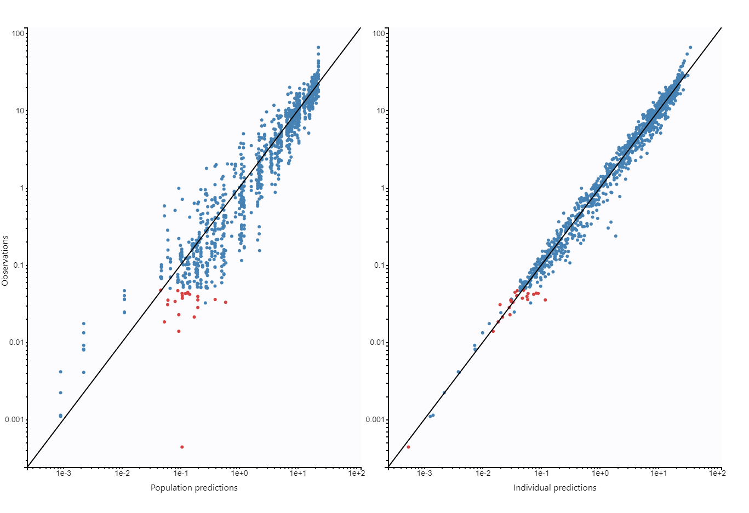
Figure s1.
Observed versus predicted concentrations in log-log plots. Left panel shows the observations versus populations predictions. The right panel shows the observations versus individual predictions.

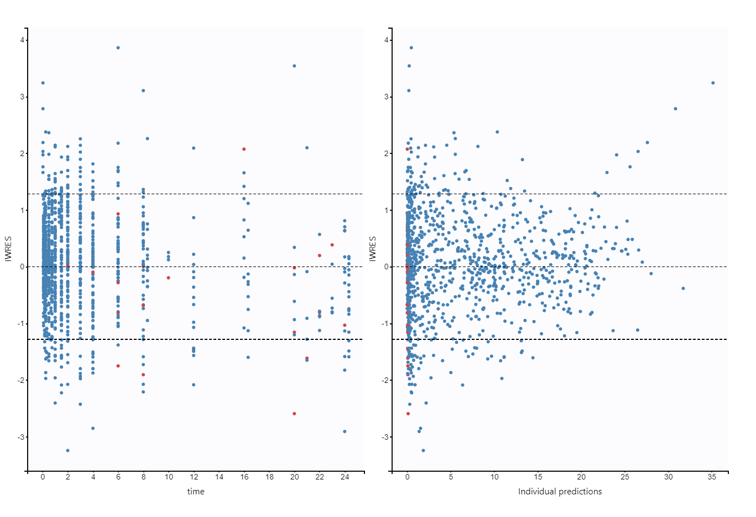
Figure S2
Plots of the population/individual-weighted residuals (PWRES and IWRES) versus predictions/time

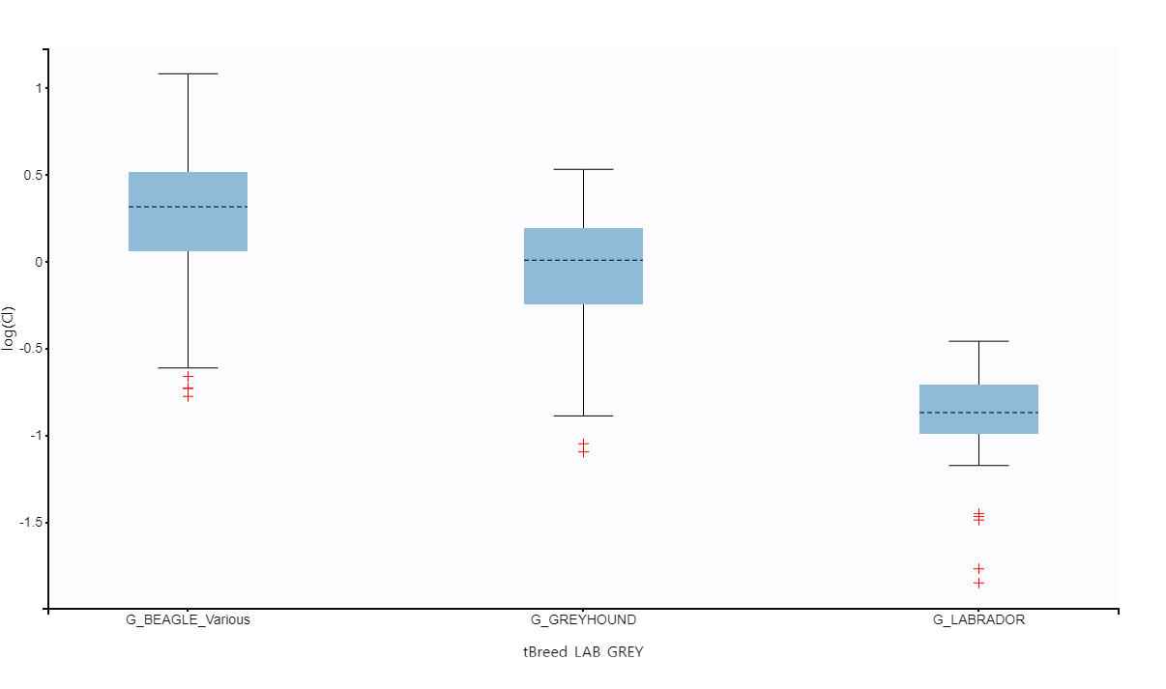
Figure S3: Box plots for covariate effect of the breed in the typical values of the clearance of paracetamol in dogs. Left box for Beagle and various group, central box for Greyhound group and right box for Labrador. Red values are points fall outside the IQR range

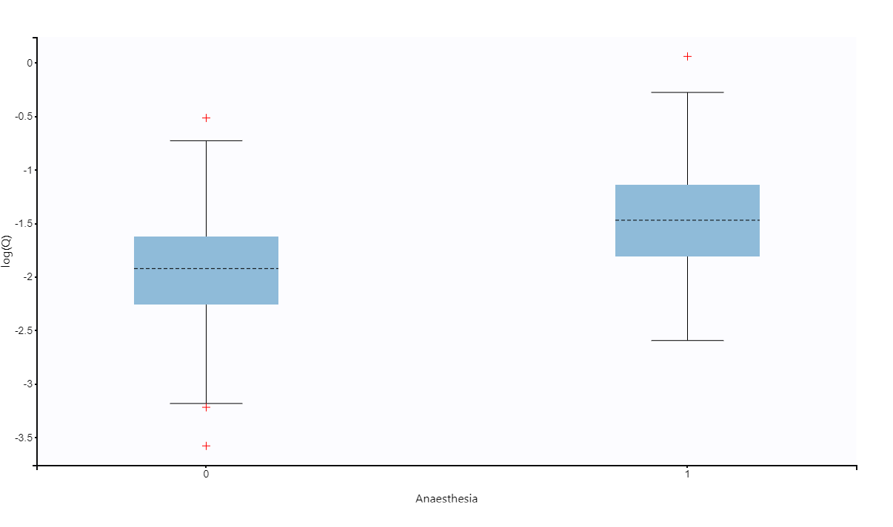
Figure S4: Box plots for covariate effect of the anaesthesia in the typical values of the intercompartmental clearance of paracetamol in dogs. Left box for animals without anaesthesia (group 0) and right box under general anaesthesia (group 1). Red values are points fall outside the IQR range

Table S1. Probability of target attainment (PTA) of simulated dose regimen of paracetamol using as target the percentage of individuals that all concentrations remain above the dosing interval. Values calculated with concentrations from 1 to 20 µg/ml using the Monte Carlo simulation (n = 1000).
 | Targets concentration in µg/mL
Beagles | 0.1 | 0.5 | 1 | 5 | 10 | 15 | 20
1 mg/kg TID | 27.20 | 12.36 | 9.57 | 0.00 | 0.00 | 0.00 | 0.00
5 mg/kg TID | 50.38 | 26.88 | 19.95 | 9.76 | 0.05 | 0.00 | 0.00
10 mg/kg TID | 64.88 | 34.88 | 27.00 | 12.35 | 9.56 | 1.35 | 0.06
15 mg/kg TID | 75.57 | 41.47 | 31.92 | 15.09 | 11.98 | 9.93 | 3.36
20 mg/kg TID | 79.79 | 46.17 | 35.65 | 17.88 | 12.40 | 11.89 | 9.69
30 mg/kg TID | 86.85 | 53.81 | 41.12 | 21.89 | 14.81 | 12.32 | 12.01
Various | 0.1 | 0.5 | 1 | 5 | 10 | 15 | 20
1 mg/kg TID | 27.64 | 12.43 | 9.98 | 0.00 | 0.00 | 0.00 | 0.00
5 mg/kg TID | 51.21 | 27.45 | 20.40 | 9.67 | 0.01 | 0.00 | 0.00
10 mg/kg TID | 64.50 | 35.56 | 27.13 | 12.44 | 9.81 | 1.51 | 0.04
15 mg/kg TID | 65.17 | 34.69 | 26.88 | 12.31 | 9.63 | 1.50 | 0.06
20 mg/kg TID | 65.82 | 35.75 | 27.54 | 12.40 | 9.80 | 1.45 | 0.04
30 mg/kg TID | 86.37 | 53.42 | 40.42 | 21.62 | 14.75 | 12.33 | 11.98
Greyhound | 0.1 | 0.5 | 1 | 5 | 10 | 15 | 20
1 mg/kg TID | 37.21 | 14.08 | 9.90 | 0.00 | 0.00 | 0.00 | 0.00
5 mg/kg TID | 69.42 | 36.48 | 26.43 | 10.12 | 0.10 | 0.00 | 0.00
10 mg/kg TID | 83.86 | 50.69 | 37.57 | 14.53 | 10.02 | 1.50 | 0.02
15 mg/kg TID | 89.50 | 57.91 | 43.26 | 19.45 | 12.29 | 10.03 | 3.65
20 mg/kg TID | 91.87 | 65.48 | 49.95 | 23.78 | 14.35 | 11.98 | 10.15
30 mg/kg TID | 94.95 | 73.97 | 58.06 | 28.78 | 19.50 | 14.18 | 12.17
Labrador | 0.1 | 0.5 | 1 | 5 | 10 | 15 | 20
1 mg/kg TID | 77.05 | 28.16 | 11.55 | 0.00 | 0.00 | 0.00 | 0.00
5 mg/kg TID | 95.85 | 75.81 | 55.70 | 11.57 | 0.10 | 0.00 | 0.00
10 mg/kg TID | 96.68 | 88.95 | 76.58 | 27.72 | 11.29 | 2.42 | 0.19
15 mg/kg TID | 96.98 | 93.84 | 85.60 | 39.47 | 19.63 | 11.45 | 4.81
20 mg/kg TID | 96.92 | 94.94 | 89.13 | 49.16 | 28.05 | 16.87 | 11.34
30 mg/kg TID | 96.99 | 95.76 | 92.75 | 61.18 | 39.27 | 27.62 | 19.74
Humans | 0.1 | 0.5 | 1 | 5 | 10 | 15 | 20
1 mg/kg TID | 89.26 | 39.94 | 20.63 | 1.21 | 0.76 | 0.01 | 0.00
5 mg/kg TID | 96.99 | 89.84 | 71.70 | 21.04 | 6.51 | 4.42 | 2.64
10 mg/kg TID | 97.00 | 96.11 | 89.28 | 40.21 | 20.78 | 12.71 | 8.47
15 mg/kg TID | 97.00 | 96.84 | 94.89 | 53.88 | 31.02 | 20.64 | 14.68
20 mg/kg TID | 97.00 | 96.99 | 96.23 | 64.46 | 40.60 | 28.46 | 21.37
30 mg/kg TID | 97.00 | 96.97 | 96.83 | 77.45 | 53.92 | 40.24 | 31.24

- Web address of 3D interactive widgets for simulation plots dosing regimen (x axis), target concentration (y axis) and probability of target attainment (z axis).
R-generated online interactive widgets sowing the relationship between average PTA, dosing regimen (mg/kg/d) and efficacy target concentration .
Please see here: https://github.com/JMSerranoRodriguez/supplementary_paracetamol_dogs.git

